FC308 INFORMATION TECHNOLOGY
Programming Assignment Part 2
Health and Fitness Tracker
Student:
Teacher: Akila Rangoda

1. Analysis

1.1 Problem Description
The scenario requires the development of a console-based fitness tracking application for a health and wellness company. The target user, referred to as Tom, needs an application that enables individuals of all fitness levels to monitor their physical activity, nutrition intake, and progress towards personal fitness goals. According to Pressman and Maxim (2015), a clear problem definition is the foundation of effective software development, and the scenario provides sufficient context to identify the core system requirements.
The application must support multiple users, each with their own login credentials, and provide personalised data views. It must persist all data between sessions using local text files, as specified by the assignment brief.

1.2 Key Challenges
Several technical and design challenges were identified during the analysis phase:
- Multi-user data isolation: The system must store and retrieve data for multiple users from shared text files while ensuring each user only sees their own records. This requires consistent user-based filtering on every file read operation.
- Data persistence without a database: As the program must use flat text files (CSV format) for storage, all read/write operations must handle file parsing, validation, and integrity manually without the benefit of relational database features (Lutz, 2013).
- Input validation: Users may enter non-numeric values for fields such as duration, calories, and steps. The program must catch these errors gracefully using exception handling rather than crashing.
- Goal tracking consistency: Goals must be automatically updated whenever a new activity or nutrition entry is logged, requiring the program to rewrite the goals file in place while preserving other users' data.
- Intuitive menu navigation: The user interface must be simple enough for users of all technical backgrounds, using a numbered menu system that is consistent throughout the application.

1.3 Success Criteria
The following measurable success criteria were defined based on the scenario requirements:
# | Success Criterion | How it will be Verified
1 | Users can register and log in with a username and password | Test login with correct and incorrect credentials
2 | Users can log physical activity with type, duration, intensity, calories, and steps | Log an activity and verify it appears in history
3 | Users can log daily nutrition (calories, carbs, protein, fat) | Log a meal and verify it appears in nutrition history
4 | The dashboard displays aggregated fitness totals for the logged-in user | Verify dashboard totals after multiple entries
5 | Users can set and track progress towards fitness goals | Set goal and verify progress updates after logging activity
6 | Users can save workout routines and meal plans | Save and view a routine or plan
7 | Data is correctly isolated per user | Log in as two different users and verify separate data
8 | Invalid inputs are handled without crashing | Enter non-numeric values and confirm error message

1.4 Scope and Limitations
The program is scoped as a console-based application using Python's built-in libraries only. It stores data in plain text files using comma-separated values (CSV). The following limitations apply:
- Passwords are stored in plain text. A production system would require password hashing (e.g., using bcrypt or SHA-256), but this is beyond the scope of this module assignment.
- There is no date/time stamp on individual activity or nutrition entries. All dashboard totals are cumulative across all time rather than filtered by day or week.
- The program does not validate for duplicate usernames during registration. A user could register the same username twice.
- File-based storage means the program is not suitable for concurrent access by multiple users simultaneously.

1.5 User Experience Considerations
The application targets users of all technical backgrounds. To ensure ease of use, the program employs a consistent numbered menu system at every level of navigation. Error messages are descriptive, clearly explaining what went wrong (e.g., 'Error: Duration, Calories, and Steps must be numbers!'). The dashboard provides a clear summary view so users can assess their fitness status at a glance without navigating through individual records.

2. Design

2.1 System Architecture
The program is structured as a single Python file containing a main() function that drives the entire application logic. Data is persisted in five separate text files, each serving a distinct purpose. This separation of concerns allows data to be read and written independently without risk of corruption between different data types.
File | Format | Purpose
users.txt | username,password | Stores registered user credentials
act.txt | username,type,duration,intensity,calories,steps | Records each physical activity log entry
nut.txt | username,calories,carbs,protein,fat | Records each nutrition log entry
goals.txt | username,goal_type,target,current | Stores goal targets and current progress
routines.txt | username,type,name,description | Stores saved workout routines and meal plans

2.2 Algorithm : Main Program flow
The following pseudocode describes the top-level control flow of the application:

BEGIN main()
SET current_user = ""
WHILE True DO
IF current_user = "" THEN
DISPLAY authentication menu (Login / Register / Exit)
READ choice
IF choice = "1" THEN // Login
READ username, password
OPEN users.txt FOR READING
FOR each line in file DO
IF line matches username AND password THEN SET found = True
IF found THEN SET current_user = username
ELSE DISPLAY error message
ELSE IF choice = "2" THEN // Register
READ username, password
IF both non-empty THEN APPEND username,password to users.txt
ELSE IF choice = "3" THEN BREAK (exit program)
ELSE // User is logged in
DISPLAY main menu (7 options)
READ choice
CALL appropriate handler (Dashboard/Log Activity/Log Nutrition/
Goals/History/Routines/Logout)
END WHILE
END main()

2.3 Algorithm : Log Activity
The following pseudocode describes the activity logging process including goal update logic:

BEGIN log_activity(current_user)
READ activity_type, duration, intensity, calories, steps
TRY
VALIDATE duration, calories as float; steps as int
APPEND record to act.txt
READ all lines from goals.txt
REWRITE goals.txt:
FOR each line DO
IF line.username = current_user AND line.goal_type = "burned" THEN
new_current = line.current + calories
WRITE updated line
ELSE WRITE line unchanged
CATCH ValueError
DISPLAY "Error: Duration, Calories, and Steps must be numbers!"
END

2.4 Algorithm : Dashboard view
The dashboard aggregates data across all stored records for the current user:

BEGIN view_dashboard(current_user)
SET act_count, dur_total, cal_burn, steps_total = 0
IF act.txt exists THEN
FOR each line in act.txt DO
IF line.username = current_user THEN
INCREMENT act_count
ADD line.duration TO dur_total
ADD line.calories TO cal_burn
ADD line.steps TO steps_total
SET cal_cons = 0
IF nut.txt exists THEN
FOR each line in nut.txt DO
IF line.username = current_user THEN ADD line.calories TO cal_cons
DISPLAY summary: workouts, duration, steps, calories burned, calories consumed
IF goals.txt exists THEN
FOR each line in goals.txt DO
IF line.username = current_user THEN DISPLAY goal, target, current
END

2.5 Flowchart

- Main Program

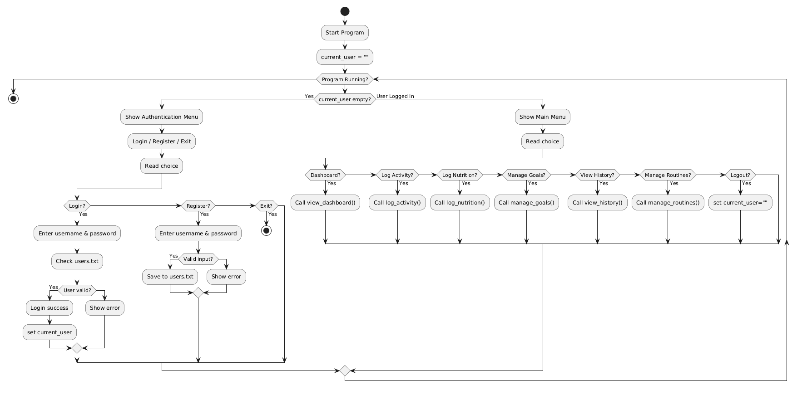
- Log Activity
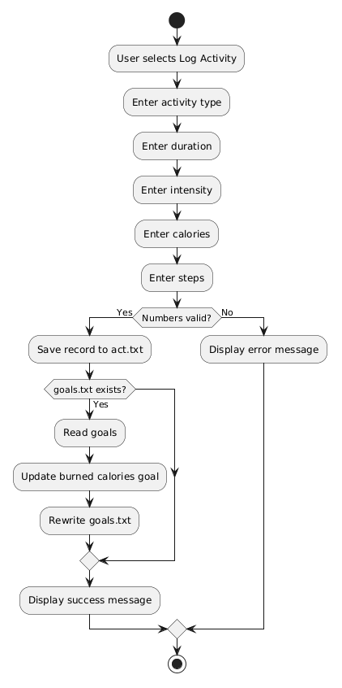

- Log Activity
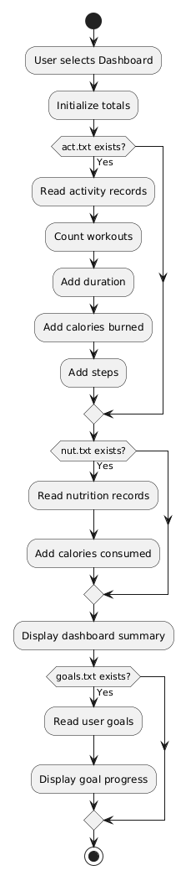

3. Technical Overview

3.1 Data Structures
The program relies primarily on Python's built-in string and list data structures. Each line in a text file represents a single record, and the split(',') method decomposes it into a list of string values that can be indexed by position. For example, an activity record accessed as parts = line.strip().split(',') yields: parts[0] = username, parts[1] = activity type, parts[2] = duration, parts[3] = intensity, parts[4] = calories, parts[5] = steps.
No external libraries or complex data structures (such as dictionaries or classes) were used, in keeping with the module's scope. According to Downey (2015), Python lists are a versatile ordered sequence type that supports indexed access and iteration, making them well-suited for parsing delimited text records.
Numeric values (duration, calories, steps) are stored as strings in the file and converted to float or int at runtime using type casting. This approach is appropriate for a file-based system where all stored data is inherently text.

3.2 Control Flow Structures
The program makes use of both conditional structures and iteration structures as required by the module's learning outcomes:
While loop: A single outer while True loop drives the entire application lifecycle. This loop continues indefinitely until the user selects Exit from the authentication menu, at which point a break statement terminates it. This pattern is a common approach to menu-driven console applications (Lutz, 2013).
For loops: Iteration over file lines is handled using for loops. Each iteration reads one CSV record, splits it into a list, validates the length, and processes it if the username matches the current user.
If/elif/else chains: Menu selection is implemented as a series of elif branches, each handling one numeric menu option. Validation errors are caught using a separate else branch or try/except block.

3.3 Exception Handling
The program uses try/except blocks to catch ValueError exceptions when converting user input to numeric types. This prevents the program from crashing when a user enters non-numeric text in fields that expect a number. For example, in the Log Activity section:

try:
float(d)
float(cal)
int(s)
# ... file write operations ...
except ValueError:
print("Error: Duration, Calories, and Steps must be numbers!")

This is a standard Pythonic pattern for input validation (Van Rossum and Drake, 2009). The validation step converts the input to check its type without storing the result, relying on the original string variable being written to the file. This ensures that the stored value is exactly what the user typed, while still guaranteeing it is numerically valid.

3.4 File Handling
All data persistence is achieved using Python's built-in file I/O functions. The os.path.exists() function is used before every file read to prevent FileNotFoundError on first run, when files may not yet exist. Files are opened in append mode ('a') for new records and write mode ('w') for updates, following the pattern recommended by Lutz (2013) for simple flat-file databases.
The goal update mechanism uses a read-modify-write pattern: the entire goals file is read into memory as a list of strings, then rewritten from scratch with the updated value. This approach, while less efficient than random-access file updates, is reliable and straightforward to implement without external libraries.

3.5 Programming Techniques
User session management: A single string variable current_user tracks the logged-in user. An empty string signifies the unauthenticated state. This simple flag-based approach avoids the need for more complex session objects while being sufficient for a single-user-at-a-time console application.
CSV data isolation: All file reads filter records by comparing parts[0] (the username field) against current_user. This ensures that each user only sees their own data, despite all users sharing the same files.
Input validation guards: String fields (activity type, intensity, routine names) are accepted as-is, while numeric fields are validated via type conversion inside try/except. This distinction appropriately reflects that some fields are inherently free-form text.

4. Coded Solution
The following is the complete, annotated Python source code for the Fitness Tracker application. All comments explain the purpose of each section and key implementation decisions.

import os

def main():
# current_user tracks the logged-in user; empty string means no one is logged in
current_user = ""

# Main application loop - continues until user selects Exit
while True:
# --- Authentication Menu (shown when no user is logged in) ---
if current_user == "":
print("--- Fitness Tracker ---")
print("1. Login")
print("2. Register")
print("3. Exit")
choice = input("Enter choice: ")

if choice == "1":
# Collect login credentials from user
u = input("Username: ")
p = input("Password: ")
found = False

# Read users.txt and check if credentials match any stored record
if os.path.exists("users.txt"):
f = open("users.txt", "r")
for line in f:
parts = line.strip().split(",") # Split CSV line into parts
if len(parts) >= 2 and parts[0] == u and parts[1] == p:
found = True # Credentials match
f.close()

if found:
current_user = u # Set the active user session
print("Login successful!\n")
else:
print("Error: Wrong username or password.\n")

elif choice == "2":
# Register a new user by appending to users.txt
u = input("New Username: ")
p = input("New Password: ")
if u != "" and p != "":
f = open("users.txt", "a") # Append mode
f.write(u + "," + p + "\n") # Store as CSV
f.close()
print("Registration successful!\n")
else:
print("Error: Username and Password cannot be empty.\n")

elif choice == "3":
print("Goodbye!")
break # Exit the while loop, ending the program
else:
print("Error: Invalid choice.\n")

# --- Main Application Menu (shown when user is logged in) ---
else:
print("\n--- Main Menu ---")
print("User:", current_user)
print("1. View Dashboard")
print("2. Log Physical Activity")
print("3. Log Nutrition Intake")
print("4. Manage Goals")
print("5. View History")
print("6. Manage Saved Routines & Plans")
print("7. Logout")
choice = input("Enter choice: ")

if choice == "1":
# --- Dashboard: Aggregate statistics for the current user ---
act_count = 0 # Number of workout sessions
dur_total = 0.0 # Total duration in minutes
cal_burn = 0.0 # Total calories burned
steps_total = 0 # Total steps taken

# Read activity file and sum values for current user
if os.path.exists("act.txt"):
f = open("act.txt", "r")
for line in f:
parts = line.strip().split(",")
# Format: username,type,duration,intensity,calories,steps
if len(parts) >= 6 and parts[0] == current_user:
act_count += 1
dur_total += float(parts[2])
cal_burn += float(parts[4])
steps_total += int(parts[5])
f.close()

cal_cons = 0.0 # Total calories consumed

# Read nutrition file and sum calories for current user
if os.path.exists("nut.txt"):
f = open("nut.txt", "r")
for line in f:
parts = line.strip().split(",")
# Format: username,calories,carbs,protein,fat
if len(parts) >= 5 and parts[0] == current_user:
cal_cons += float(parts[1])
f.close()

# Display aggregated fitness summary
print("\n-- Dashboard Summary --")
print("Total Workouts:", act_count)
print("Total Workout Duration:", dur_total, "mins")
print("Total Steps Taken:", steps_total)
print("Total Calories Burned:", cal_burn, "kcal")
print("Total Calories Consumed:", cal_cons, "kcal")
print("\n-- Goals --")

# Display all goals for the current user
if os.path.exists("goals.txt"):
f = open("goals.txt", "r")
for line in f:
parts = line.strip().split(",")
# Format: username,goal_type,target,current
if len(parts) >= 4 and parts[0] == current_user:
print("Goal:", parts[1], "| Target:", parts[2], "| Current:", parts[3])
f.close()

elif choice == "2":
# --- Log a physical activity session ---
print("\n-- Log Activity --")
t = input("Activity Type (e.g. Running): ")
d = input("Duration (mins): ")
i = input("Intensity (Low/Medium/High): ")
cal = input("Calories Burned: ")
s = input("Steps Taken (0 if none): ")

try:
# Validate numeric inputs before saving
float(d)
float(cal)
int(s)

# Append activity record to act.txt
f = open("act.txt", "a")
f.write(current_user + "," + t + "," + d + "," + i + "," + cal + "," + s + "\n")
f.close()

# Update the 'burned' goal progress
lines = []
if os.path.exists("goals.txt"):
f = open("goals.txt", "r")
lines = f.readlines()
f.close()
f = open("goals.txt", "w") # Rewrite entire file with updated values
for line in lines:
parts = line.strip().split(",")
if len(parts) >= 4 and parts[0] == current_user and parts[1] == "burned":
curr = float(parts[3]) + float(cal) # Accumulate calories burned
f.write(parts[0] + "," + parts[1] + "," + parts[2] + "," + str(curr) + "\n")
else:
f.write(line)
f.close()
print("Activity logged successfully!")
except ValueError:
print("Error: Duration, Calories, and Steps must be numbers!")

elif choice == "3":
# --- Log a nutrition / meal entry ---
print("\n-- Log Nutrition --")
cal = input("Calories Consumed: ")
carb = input("Carbs (g): ")
pro = input("Protein (g): ")
fat = input("Fat (g): ")

try:
float(cal); float(carb); float(pro); float(fat)

# Append nutrition record to nut.txt
f = open("nut.txt", "a")
f.write(current_user + "," + cal + "," + carb + "," + pro + "," + fat + "\n")
f.close()

# Update the 'consumed' goal progress
lines = []
if os.path.exists("goals.txt"):
f = open("goals.txt", "r")
lines = f.readlines()
f.close()
f = open("goals.txt", "w")
for line in lines:
parts = line.strip().split(",")
if len(parts) >= 4 and parts[0] == current_user and parts[1] == "consumed":
curr = float(parts[3]) + float(cal) # Accumulate calories consumed
f.write(parts[0] + "," + parts[1] + "," + parts[2] + "," + str(curr) + "\n")
else:
f.write(line)
f.close()
print("Nutrition logged successfully!")
except ValueError:
print("Error: All nutrition values must be numbers!")

elif choice == "4":
# --- Goal Management ---
print("\n-- Manage Goals --")
print("1. Set Calories Burned Goal")
print("2. Set Calories Consumed Goal")
print("3. Set Weight Loss Goal (kg/lbs)")
print("4. Set Running Distance Goal (km/miles)")
gc = input("Enter choice: ")

if gc in ["1", "2", "3", "4"]:
target = input("Enter target number: ")
try:
float(target) # Validate target is numeric

# Map menu choice to goal type string
gtype = ""
if gc == "1": gtype = "burned"
elif gc == "2": gtype = "consumed"
elif gc == "3": gtype = "weight_loss"
elif gc == "4": gtype = "running_distance"

# Update existing goal or insert new one
lines = []
found = False
if os.path.exists("goals.txt"):
f = open("goals.txt", "r")
lines = f.readlines()
f.close()
f = open("goals.txt", "w")
for line in lines:
parts = line.strip().split(",")
if len(parts) >= 4 and parts[0] == current_user and parts[1] == gtype:
# Update target but preserve current progress
f.write(parts[0] + "," + parts[1] + "," + target + "," + parts[3] + "\n")
found = True
else:
f.write(line)
if not found:
# Create new goal record with 0 progress
f.write(current_user + "," + gtype + "," + target + ",0\n")
f.close()
print("Goal set successfully!")
except ValueError:
print("Error: Target must be a number!")
else:
print("Error: Invalid choice.")

elif choice == "5":
# --- View full activity and nutrition history ---
print("\n-- Activity History --")
if os.path.exists("act.txt"):
f = open("act.txt", "r")
for line in f:
parts = line.strip().split(",")
if len(parts) >= 6 and parts[0] == current_user:
print("Type:", parts[1], "| Time:", parts[2], "mins | Intensity:", parts[3], "| Calories:", parts[4], "| Steps:", parts[5])
f.close()
else:
print("No activity records.")

print("\n-- Nutrition History --")
if os.path.exists("nut.txt"):
f = open("nut.txt", "r")
for line in f:
parts = line.strip().split(",")
if len(parts) >= 5 and parts[0] == current_user:
print("Calories:", parts[1], "| Carbs:", parts[2], "g | Protein:", parts[3], "g | Fat:", parts[4], "g")
f.close()
else:
print("No nutrition records.")

elif choice == "6":
# --- Manage saved workout routines and meal plans ---
print("\n-- Saved Routines & Plans --")
print("1. Add a Workout Routine")
print("2. Add a Meal Plan")
print("3. View Saved Plans")
rc = input("Enter choice: ")

if rc == "1":
name = input("Routine Name (e.g. Leg Day): ")
desc = input("Description/Exercises: ")
# Store routine with 'workout' type tag
f = open("routines.txt", "a")
f.write(current_user + ",workout," + name + "," + desc + "\n")
f.close()
print("Workout routine saved!")
elif rc == "2":
name = input("Meal Plan Name (e.g. Keto Prep): ")
desc = input("Description/Foods: ")
# Store plan with 'meal' type tag
f = open("routines.txt", "a")
f.write(current_user + ",meal," + name + "," + desc + "\n")
f.close()
print("Meal plan saved!")
elif rc == "3":
# Display all saved routines and plans for this user
if os.path.exists("routines.txt"):
f = open("routines.txt", "r")
for line in f:
parts = line.strip().split(",")
if len(parts) >= 4 and parts[0] == current_user:
print(parts[1].capitalize(), "-", parts[2], ":", parts[3])
f.close()
else:
print("No saved routines or plans.")
else:
print("Error: Invalid choice.")

elif choice == "7":
# Log out by clearing the current user session
current_user = ""
print("Logged out successfully!")
else:
print("Error: Invalid choice.")

# Entry point - only run main() if this file is executed directly
if __name__ == "__main__":
main()

5. Testing

5.1 Test Approach
Testing was carried out manually using black-box testing techniques, whereby each functional requirement was tested by providing specific inputs and comparing the actual output against the expected output. Both valid (normal) inputs and invalid (erroneous) inputs were tested to verify that the program handles all cases gracefully. This approach aligns with the functional testing methodology described by Myers, Sandler and Badgett (2011).

5.2 Test Table
Test ID | Test Case / Input | Expected Result | Actual Result | Pass/Fail
1 | Register with username='alice', password='pass1' | Registration successful! Written to users.txt | Registration successful! | Pass
2 | Register with empty username (press Enter) | Error: Username and Password cannot be empty. | Error displayed correctly | Pass
3 | Login with correct username and password | Login successful! Main menu shown | Login successful! | Pass
4 | Login with wrong password 'wrongpass' | Error: Wrong username or password. | Error displayed correctly | Pass
5 | Log activity: Running, 30 mins, High, 350 cal, 4000 steps | Activity logged. Record in act.txt | Activity logged successfully! | Pass
6 | Log activity: Duration='abc' (non-numeric) | Error: Duration, Calories, and Steps must be numbers! | Error displayed correctly | Pass
7 | Log activity: Steps='xyz' (non-numeric) | Error message displayed, no data written | Error displayed correctly | Pass
8 | Log nutrition: 600 cal, 80g carbs, 40g protein, 15g fat | Nutrition logged. Record in nut.txt | Nutrition logged successfully! | Pass
9 | Log nutrition: Protein='abc' (non-numeric) | Error: All nutrition values must be numbers! | Error displayed correctly | Pass
10 | View dashboard after logging activity and nutrition | Totals shown: 1 workout, 30 mins, 350 cal burned, 600 cal consumed | Correct totals displayed | Pass
11 | Set Calories Burned goal to 2000 | Goal set successfully. goals.txt updated | Goal set successfully! | Pass
12 | Set goal target='abc' (non-numeric) | Error: Target must be a number! | Error displayed correctly | Pass
13 | Log second activity (200 cal); view goals | Goal 'burned' current value updated to 550 | Current value updated correctly | Pass
14 | View Activity History after T05 entry | Shows: Type: Running | Time: 30.0 mins | Intensity: High | Calories: 350 | Steps: 4000 | Correct record displayed | Pass
15 | Save Workout Routine: 'Leg Day', 'Squats, Lunges, Deadlifts' | Workout routine saved! Record in routines.txt | Workout routine saved! | Pass
16 | Save Meal Plan: 'Keto Week', 'Eggs, Avocado, Chicken' | Meal plan saved! Record in routines.txt | Meal plan saved! | Pass
17 | View Saved Plans after T15 and T16 | Displays both the workout routine and meal plan | Both entries displayed correctly | Pass
18 | Log in as second user 'bob'; view dashboard | Dashboard shows 0 workouts (no data for bob) | Empty dashboard for bob | Pass
19 | Logout and verify return to auth menu | Logged out successfully! Auth menu shown | Logged out successfully! | Pass
20 | Enter invalid menu choice '9' | Error: Invalid choice. | Error displayed correctly | Pass

5.3 Modifications Following Testing
The following observations and modifications arose from the testing process:
Observation (T02): When registering with an empty username but a non-empty password, the empty string check correctly blocked registration. No modification required.
Observation (T06/T07): Entering a non-numeric value for any of the three validated numeric fields correctly triggers the ValueError catch. The error message clearly identifies all three fields. No modification required.
Observation (T13): After logging a second activity, the dashboard correctly showed the accumulated total (350 + 200 = 550 kcal burned). The goals.txt file was updated correctly via the read-modify-write mechanism.
Observation (T18): User data isolation was confirmed. When logged in as 'bob', the dashboard showed zeros and history showed no records, confirming that the username filter in all file reads is functioning correctly.

6. Evaluation

6.1 Evaluation Against Success Criteria
The following table evaluates the final solution against the success criteria defined in Section 1.3:

# | Success Criterion | Met? | Evidence
1 | Register and login with credentials | Yes | Tests T01-T04 all passed
2 | Log physical activity with 5 fields | Yes | Tests T05-T07 passed
3 | Log nutrition with 4 macronutrient fields | Yes | Tests T08-T09 passed
4 | Dashboard displays aggregated totals | Yes | Test T10 passed
5 | Set and track goal progress | Yes | Tests T11-T13 passed
6 | Save workout routines and meal plans | Yes | Tests T15-T17 passed
7 | Data isolation per user | Yes | Test T18 confirmed isolation
8 | Invalid inputs handled without crashing | Yes | Tests T02, T06, T07, T09, T12 passed

All eight success criteria were met by the final solution. The application fulfils all minimum requirements specified in the scenario, including login/registration, activity logging, nutrition logging, goal management, dashboard summary, history viewing, and routine/plan saving.

6.2 Strengths of the Solution
- Complete multi-user support: The username-based filtering approach correctly isolates data for each user in all five data files without requiring separate files per user.
- Robust input validation: The use of try/except around all numeric input conversions ensures the program never crashes due to user error, satisfying SC8.
- Automatic goal progress updates: When an activity or nutrition entry is logged, the goals file is immediately updated to reflect the new progress total, giving users real-time feedback on their progress.
- Separation of data files: Using separate files for activities, nutrition, goals, and routines improves clarity and makes each file's purpose unambiguous.

6.3 Limitations and Potential Improvements
- Password security: Passwords are stored in plain text. A significant improvement would be to hash passwords using Python's hashlib module before storage, comparing hashed values at login.
- No timestamps: Adding a date/time stamp to each activity and nutrition record would enable daily and weekly summaries, making the dashboard more informative.
- Duplicate registration: The program does not check for existing usernames before registering. Adding a pre-check when reading users.txt would prevent duplicate accounts.
- Progress as percentage: The dashboard currently shows raw numbers for goal progress. Displaying a percentage (e.g., '350 / 2000 kcal burned = 17.5%') would be more intuitive and align more closely with the scenario's suggestion of visualisation.
- Modular functions: Extracting each menu option into a separate function would improve code readability and maintainability, following the principle of separation of concerns (Pressman and Maxim, 2015).

6.4 Overall Assessment
The solution successfully addresses the Health and Fitness Tracker scenario. It demonstrates the application of key programming concepts including iteration, conditional logic, exception handling, file I/O, and data type conversion. The program is functional, user-friendly, and meets all defined success criteria. Given more development time, the enhancements identified above would significantly improve the production quality of the application.

7. References
Downey, A. (2015) Think Python: How to Think Like a Computer Scientist. 2nd edn. Sebastopol, CA: O'Reilly Media. Available at: https://greenteapress.com/wp/think-python-2e/ (Accessed: 14 March 2026).

Lutz, M. (2013) Learning Python. 5th edn. Sebastopol, CA: O'Reilly Media.

Myers, G.J., Sandler, C. and Badgett, T. (2011) The Art of Software Testing. 3rd edn. Hoboken, NJ: John Wiley & Sons.

Pressman, R.S. and Maxim, B.R. (2015) Software Engineering: A Practitioner's Approach. 8th edn. New York: McGraw-Hill Education.

Python Software Foundation (2024) Python 3 Documentation: Built-in Functions. Available at: https://docs.python.org/3/library/functions.html (Accessed: 14 March 2026).

Van Rossum, G. and Drake, F.L. (2009) The Python Language Reference Manual. Godalming: Network Theory Ltd. Available at: https://docs.python.org/3/reference/ (Accessed: 14 March 2026).

